APPLICATION FOR CHW SCHOLARS 2014

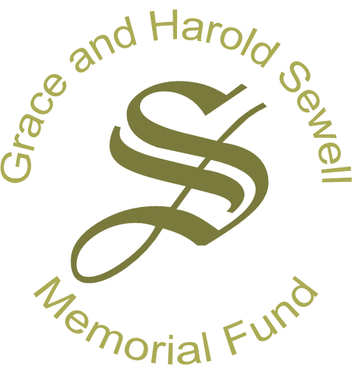

Scholarships to Attend the 142nd Annual Meeting of the

**American Public Health Association (APHA)**

With funding from the *Harold and Grace Sewell Trust Fund,* the Community Health Worker (CHW) Section of the American Public Health Association (APHA) will offer five $800 scholarships to community health workers to attend the 142nd Annual Meeting of the American Public Health Association in New Orleans, Louisiana from November 16-19, 2014.

The American Public Health Association is the world’s largest organization of public health workers. It represents health advocates, health promoters, researchers, clinicians, social workers, and many others united in improving the health of the public. To learn more about this year’s meeting, visit <http://www.apha.org> and click on Annual Meeting.

This scholarship honors the important work of grass-roots advocates who promote health in their communities. We want to bring your knowledge, experience, and commitment to the CHW field to APHA. Scholarship awardees from out of town will receive funding to help pay for transportation, room and board, meals, and registration fees. Scholarships will be paid on a reimbursable basis after the Annual Meeting in November and all written reports are received.

To be eligible for the scholarship, you must:

* Be over 18 years of age.
* Send a letter of reference on letterhead from the supervisor of your community health program. (note: this includes paid and volunteer positions)
* Submit a written a report after the Annual Meeting to be shared with the *Harold and Grace Sewell Trust Fund* and the scholarship committee. The report should highlight what you learned during the APHA Annual Meeting and be at least one page in length.
* Attend both the CHW Section Social Reception, Monday, November 17th from 6:30-8:00pm* and the CHW Section Business Meeting, Tuesday, November 18th from 6:30-8:00pm.*
* Register for APHA with the CHW Section as your primary affiliation.

Please complete the application form. Additional paper and spacing may be used, if needed.

Your completed application and letter of reference must be received by **Friday, July 25, 2014.**

CHW Section Scholarship Committee

ATTN: Dr. Susan Mayfield-Johnson

University of Southern Mississippi

118 College Drive #5122

Hattiesburg, MS 39406

Phone: (601) 266-6266 E-mail: [susan.Johnson@usm.edu](mailto:susan.Johnson@usm.edu)

*Times are subject to change, pending the arrangement of the final program.

**Electronic copies are preferred, but do request confirmation of receipt.

APPLICATION FOR CHW SCHOLARS 2014

**Scholarships to Attend the 142nd Annual Meeting of the**

**American Public Health Association (APHA):**

**November 16-19 in New Orleans, Louisiana**

**Return this application with a *letter of reference on business letterhead from your supervisor* by Friday, July 25, 2014.** Applications without both the application and the letter of reference will not be considered. Please also check for confirmation of receipt. Send to:

CHW Section Scholarship Committee

ATTN: Dr. Susan Mayfield-Johnson

University of Southern Mississippi

118 College Drive #5122

Hattiesburg, MS 39406

Phone: (601) 266-6266 E-mail: [susan.Johnson@usm.edu](mailto:susan.Johnson@usm.edu)

* Electronic copies are preferred; please request confirmation of receipt.

The Scholarship Committee will choose recipients based on:

* The specific type of community health outreach work that you do,
* Involvement in and commitment to community health outreach,
* Leadership, activity, or involvement within the CHW Section, state, local, or other national CHW association,
* Specific ways this conference will help advance your commitment to the CHW field and involvement to the CHW section, and
* Specifics about your work and leadership activities from your reference letter.
  + - 1. Your name: ______________________________________________________________
      2. Your complete mailing address:

______________________________________________________________________________________________________________________________________________________

* + - 1. Your job title: ___________________________________________________________
      2. The name of your organization and the address where you work:

__________________________________________________________________________________________________________________________________________________

* + - 1. Your phone number at work: _______________________________________________
      2. Your cell phone number: _______________________________________________
      3. Your email address: _______________________________________________________
      4. Describe how your organization (program and services) contribute to improving community health? Write 2-3 sentences describing the organization’s program/services.
      5. What role do you play in the organization? Write 2-3 sentences about YOUR work and how it affects your community.
      6. How long have you worked in this program? _________________
      7. Describe your involvement with any local, state, or other national CHW association (including the CHW Section). If you are not currently involved in any CHW association, how do you plan to become involved, and why is involvement with CHW organizations or associations so important to advancing the field?
      8. What leadership skills do you currently have? What leadership skills do you want to strengthen? Why is it important for CHWs to develop leadership skills?
      9. How would attending this APHA meeting benefit your work and activities in your community? How can your participation in the APHA Annual Meeting strengthen the CHW field?